We appreciate you being a NMGC participating contractor. As a program participant, we encourage you to share your involvement with prospective customers.

With approval, NMGC allows Participating Contractors to communicate their status with a custom co-branded logo. This logo can be used in any of your marketing materials, by following the steps below:

1. Review Usage Guidelines and Tips
2. Request your Logo
3. Share your Co-branded Marketing for Approval

------

1. Usage Guidelines and Tips

Please accurately represent your relationship as NMGC Participating Contractor. Contractors cannot represent themselves as working for, approved by, or certified by NMGC.

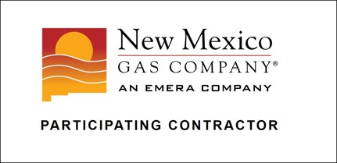

Logo Use

A. You must you use the official logo file provided by NMGC. It cannot be modified, including:
- Removing/adding text or elements
- Changing colors
- Distorting

B. Please size and place the logo correctly, including
- Minimum of 100 pixels wide when used online or one inch wide when used in print.
- Keep included white space around logo

Program Information Use

A. Rebate information

- Ensure any rebate information is up-to-date. Information is available https://www.nmgcgetrebates.com/
- If quoting multiple rebate sources, make sure it is clear which are NMGC rebates and which are from manufacturers or other utilities
- The math should be clear so the customer does not misunderstand the total rebate amount or final cost

2. Requesting Your Logo

Send your logo requests to Roy.Solomon@icf.com
- For best results, include how you plan to use i.e. on a newspaper ad, website, etc.
- Feel free to include any questions – we’re here to help.

3. Share your Co-branded Marketing for Approval

The approval process is easy!

Submit a copy of your cobranded marketing along with the following information to Roy.Solomon@icf.com
- Company name and contact
- Dates the material(s) will be used
- Where the material(s) will be used
Please note that, NMGC must review and approve in writing any material which displays our logo prior to publication.

---------------------

If the NMGC name or logo is used without permission or if the name or logo has been adapted, modified or otherwise used inappropriately, NMGC reserves the right to demand immediate cessation of such use and to pursue appropriate action or remedies, including civil or criminal prosecution.

Contact Us

If you have any questions about your participation, including cobranding assistance, please contact
Roy Solomon at Roy.Solomon@icf.com or (505) 697-9910

